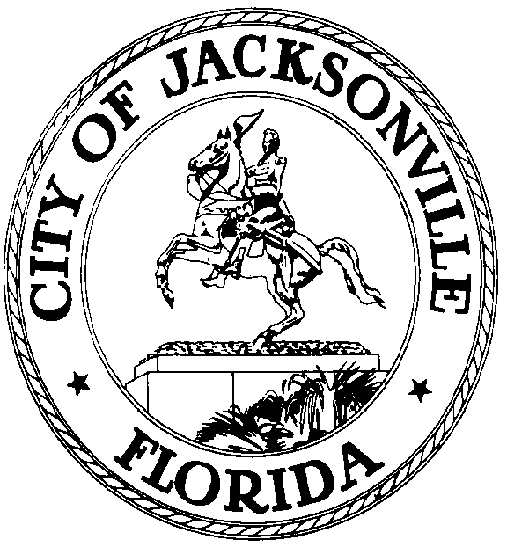

GARRETT L. DENNIS
Council Member District 9
E-Mail: GarrettD@coj.net

OFFICE OF THE CITY COUNCIL
117 West Duval Street City Hall, Suite 425
Jacksonville, Florida 32202
Office (904) 255-5209
Fax (904) 255-5230
.

MEDIA RELEASE

FOR IMMEDIATE RELEASE – October 7, 2020
Contact: Garrett Dennis (904) 887-1870

COUNCILMAN GARRETT DENNIS INTRODUCES LEGISLATION TO PROVIDE IMMEDIATE QUALITY OF LIFE FUNDING

JACKSONVILLE, Fla. – Following the announcement of the City of Jacksonville borrowing $208.3 million for Lot J, Councilman Dennis has introduced legislation to borrow an additional $41.5 million to fund Capital Improvement Projects in all 14 council districts.

“While I believe in investing in a vibrant downtown, the needs of all citizens throughout Jacksonville are just as great, if not greater. This legislation would immediately fund projects to make much-needed infrastructure improvements and increase the quality of life for citizens in every corner of Jacksonville. This funding will also address septic tank phase-outs, which is a significant need in our community,” Dennis said.

